Project Initialization and Planning Phase

Date | 26 August 2026
Team ID | -
Project Name | Food Ordering Behaviour and Consumer Trends
Maximum Marks | 3 Marks

Define Problem Statements (Customer Problem Statement Template):

Create a problem statement to understand your customer's point of view. The Customer Problem Statement template helps you focus on what matters to create experiences people will love. A well-articulated customer problem statement allows you and your team to find the ideal solution for your customers' challenges. Throughout the process, you’ll also be able to empathize with your customers, which helps you better understand how they perceive your product or service.
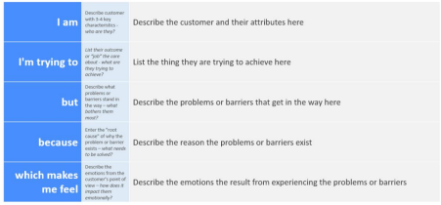
Reference: https://miro.com/templates/customer-problem-statement/
Example:
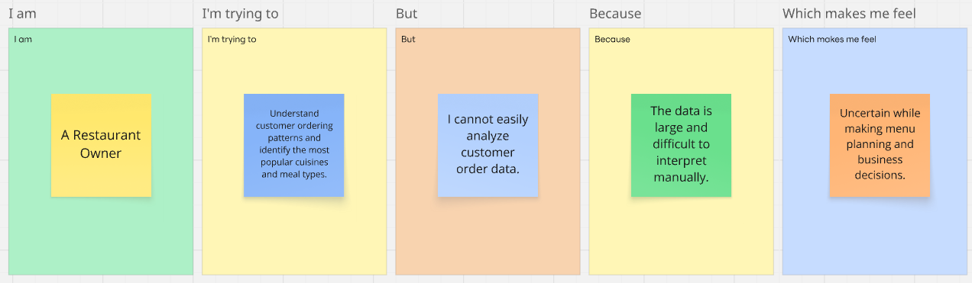

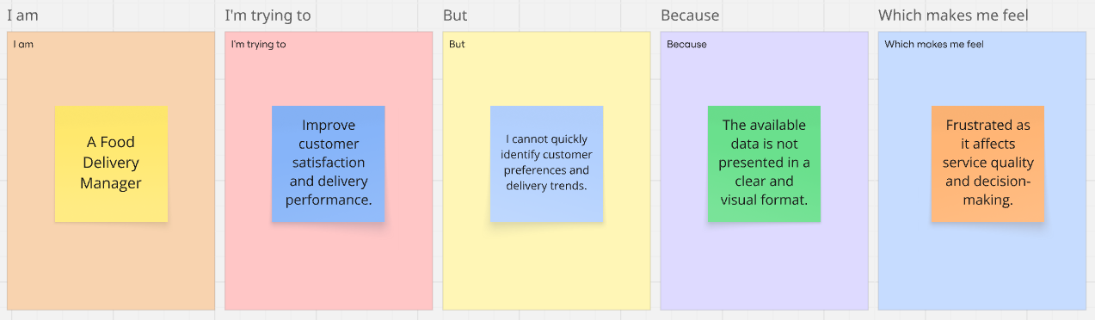

Problem  Statement (PS) | I am  (Customer) | I’m trying to | But | Because | Which makes me feel
PS-1 | A Restaurant Owner | understand customer ordering patterns and identify the most popular cuisines and meal types | I cannot easily analyze customer order data | because the data is large and difficult to interpret manually | uncertain while making menu planning and business decisions
PS-2 | A Food Delivery Manager | improve customer satisfaction and delivery performance | I cannot quickly identify customer preferences and delivery trends | because the available data is not presented in a clear and visual format | frustrated as it affects service quality and decision-making

